Name: ________________________________________ Date: _____________________
Class: ______________________________
1810 House

Directions: After your tour of the historic sites of Warwick, answer the following questions. Use the links from the web site and the information you gathered from the tour to help you answer the questions.

1. What was the name of the family that built the 1810 House? _________________________

2. The 1810 House has had many occupants and uses over the years. List some of its occupants and uses:
_____________________________________________________________________________
_____________________________________________________________________________
_____________________________________________________________________________

3. On the left side of the downstairs is the Forester Room which contains the mementos of the author, Frank Forester. What was Frank Forester’s real name? ___________________________________________________________________________
What is the title of one of his best know books?
___________________________________________________________________________
What did he write about?
____________________________________________________________________________
What are some of Frank Forester’s hunting accessories that are on display?
____________________________________________________________________________

4. Also located in the Frank Forester room is a chair owned by William H. Seward. Who was William H. Seward and what did he purchase?
____________________________________________________________________________

____________________________________________________________________________

5. There is a child’s high chair in the room across from the Forester room]. Who used this high chair and why is he famous?
____________________________________________________________________________

6. Outside of the 1810 House there is a garden that was created in the style of the period of the House. What type of garden is it?
____________________________________________________________________________
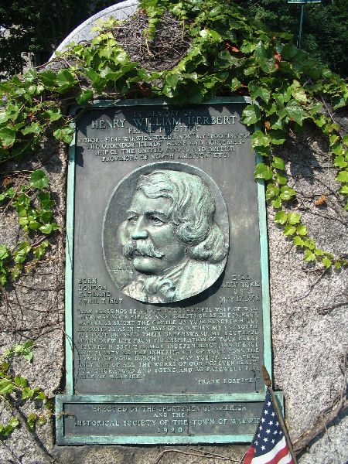
7. The plaque shows the face is that of Frank Forester. Where in the village of Warwick will you see this plaque of Frank Forester today?
______________________________________________________
______________________________________________________

