Name: ________________________________________ Date: _____________________
Class: ______________________________
Baird’s Tavern
Directions: After your tour of the historic sites of Warwick, answer the following questions. Use the links from the web site and the information you gathered from the tour to help you answer the questions.

1. In what year did Francis Baird build the tavern? ________________________
2. Why was the location of the tavern an excellent choice in Colonial Warwick?

3. How much did it cost to spend the night there? ____________ How much did cost to spent the night there if you wanted supper too? _______________
4. Name one notable guest who stayed overnight at Baird's Tavern? ______________ Name another notable guest who dined at the tavern. __________________________ What proof do we have that this is true? _____________________________________
______________________________________________________________________
5. How much did a bowl of Flip cost? _______ What is Flip (you can do a Google search for “bowl or flip”)? _________________________________________________

6. Why was part of the wall in the upstairs’ room hanging from the ceiling? _________

7. Describe one of the upstairs’ bedrooms (examples – about how big is it, where are the clothes stored, what is hanging on the walls, how is the room kept warm, how did people wash, etc.)
______________________________________________________________________
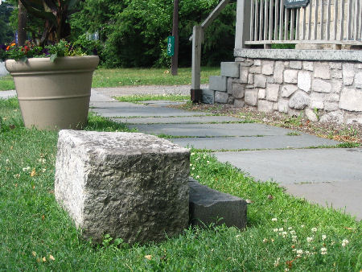
______________________________________________________________________
______________________________________________________________________
______________________________________________________________________
8. This stone block is found by the curb on Main Street outside of Baird’s Tavern. What do you think it was used for? (Hint: Think of the way people used to travel in Colonial Times.)
____________________________
____________________________
____________________________
____________________________

9. Why did the Warwick militia meet in the attic during winter months? ____________
______________________________________________________________________
______________________________________________________________________
______________________________________________________________________

