Historical Society of the Town of Warwick

Museum Buildings

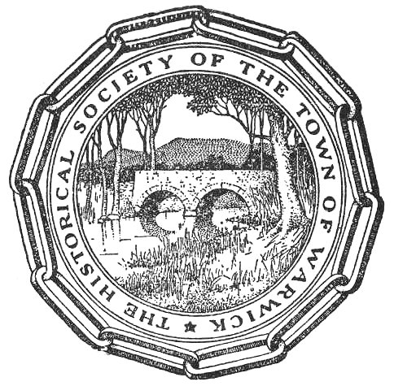

Updated from the Original Descriptions in
“Review of the Activities of the Historical Society of the Town of Warwick”
by Robert Richmond

2004

Historical Society of the Town of Warwick
Phone: (845)-986-3236
P.O. Box 353
Warwick, NY 10990

The document in its entirety can be found
on the Historical Society website at:
http://www.warwickhistoricalsociety.org/docs/mbb.pdf

The Shingle House

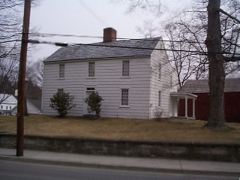
Located on Forester Avenue, the Shingle House was the first building acquired by the Society. It was built in 1764 by Daniel Burt for his son Daniel Jr. He chose an excellent location, next to where The King’s Highway passed. The Highway was a major colonial route from Pennsylvania and New Jersey up to the Hudson River and New England. Daniel Sr. lived in a home on the site of what is now the McFarland house on Galloway Road (17A), and in going back and forth between his own house and his son’s, he created what was then called Burt’s Lane, later known as Lake St., and now named Forester Avenue, in honor of famous author and sportsman Frank Forester (Henry William Herbert) who visited and hunted in Warwick frequently in the early 1800’s. A memorial plaque to him stands a short distance away in the traffic island at the intersection of Colonial Ave. and Main St.
The Shingle House, with its shingled sides and saltbox outline, reveals its New England heritage. According to local oral histories, the shingles for its sides and roof were hewn from a single tree. Few of them have had to be replaced in the house’s 215 years. A small rear porch and ground floor wing on the northwest are the only exterior alterations.
Inside, the original stairway, the characteristic paneled wainscoting, built-in corner cupboard with decorative shell top, and remarkable central chimney with four fireplaces and its hidey-hole, are still for the most part as they were when Daniel, Jr. moved in, in January 1770. The ‘hidey-hole’ is also referred to in some writings as the ‘Tory hole’. During the revolution the area was subject to raids and counter-raids by loyalist and revolutionary groups, and as the Burts were a Whig family, it is likely they made this secret space as a refuge from Tories.
The house has six rooms, four on the first floor. The two front ones were both living rooms. The fireplace in the left-hand room was closed up many years ago, and a Franklin cast-iron stove placed in front of it. It is on the paneling above this stove that ones finds the unusual and rare primitive paining of the Battle of the Hudson River, said to have been done by a Revolutionary soldier in gratitude for having been nursed back to health by the Burts.
The Shingle House was bought by the Historical Society in 1916, and since then considerable restoration has been done. A Chippendale Governor Winthrop desk, a Hepplewhite cherry Pembroke table, a Chippendale mahogany book case desk, a Sheraton mahogany chair are among the furnishings.
The huge kitchen features a tremendous open hearth for cooking, beehive bread oven, Dutch walnut kaas (a kaas was used as a wardrobe cabinet and was also used for storage of linens and blankets), primitive table and bench, and numerous household implements of the late 1770’s.
The first floor “borning room is so called because this room nearest the fireplace and kitchen was used for pregnant women, as well as the sick and elderly. The two upstairs bedrooms are also appropriately furnished in period pieces. Location: Forester Ave. near the corner of Church St.

Lehigh and Hudson River Railroad Caboose at the Shingle House

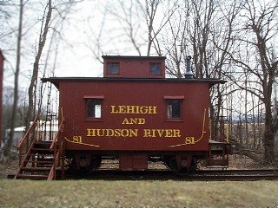
In the late 1970’s, Edmund H. Brown, Jr., Vice-President of the Lehigh and Hudson River Railway Company, was fearful that with the ending of the L & HR as an operating entity, all physical evidence of the industry which played a key role in the history of Warwick might vanish. Upon learning of the impending destruction of the antiquated caboose No. 81, he resolved to save it for posterity. He purchased it from the Trustee of the railroad and presented it to the Village for a museum. The plan never came to fruition, however, and it was eventually deeded to the Historical Society. On May 14, 1979, the “Four-Wheel Red Work Horse” was installed on this very spot. Today it is opened during museum house for all to tour and glimpse a bit of railroad history.
The caboose was built in 1890. It is a small four wheeler, equipped with four bunks, stove, desk, and lamps. It was used extensively by repair crews as a home away from home for plowing, track laying, and derailment crews. In later years it was used primarily as a crew space when laying and repairing rail. Flat cars were loaded with various weights of rail, the caboose added, and all were pulled to locations where rails needed replacing. It provided shelter during storms, a place to get warm, rest, and have a hot cup of coffee. The “Work Horse” took good care of the crew until they were ready to head home again.

The Sly Barn at the Shingle House

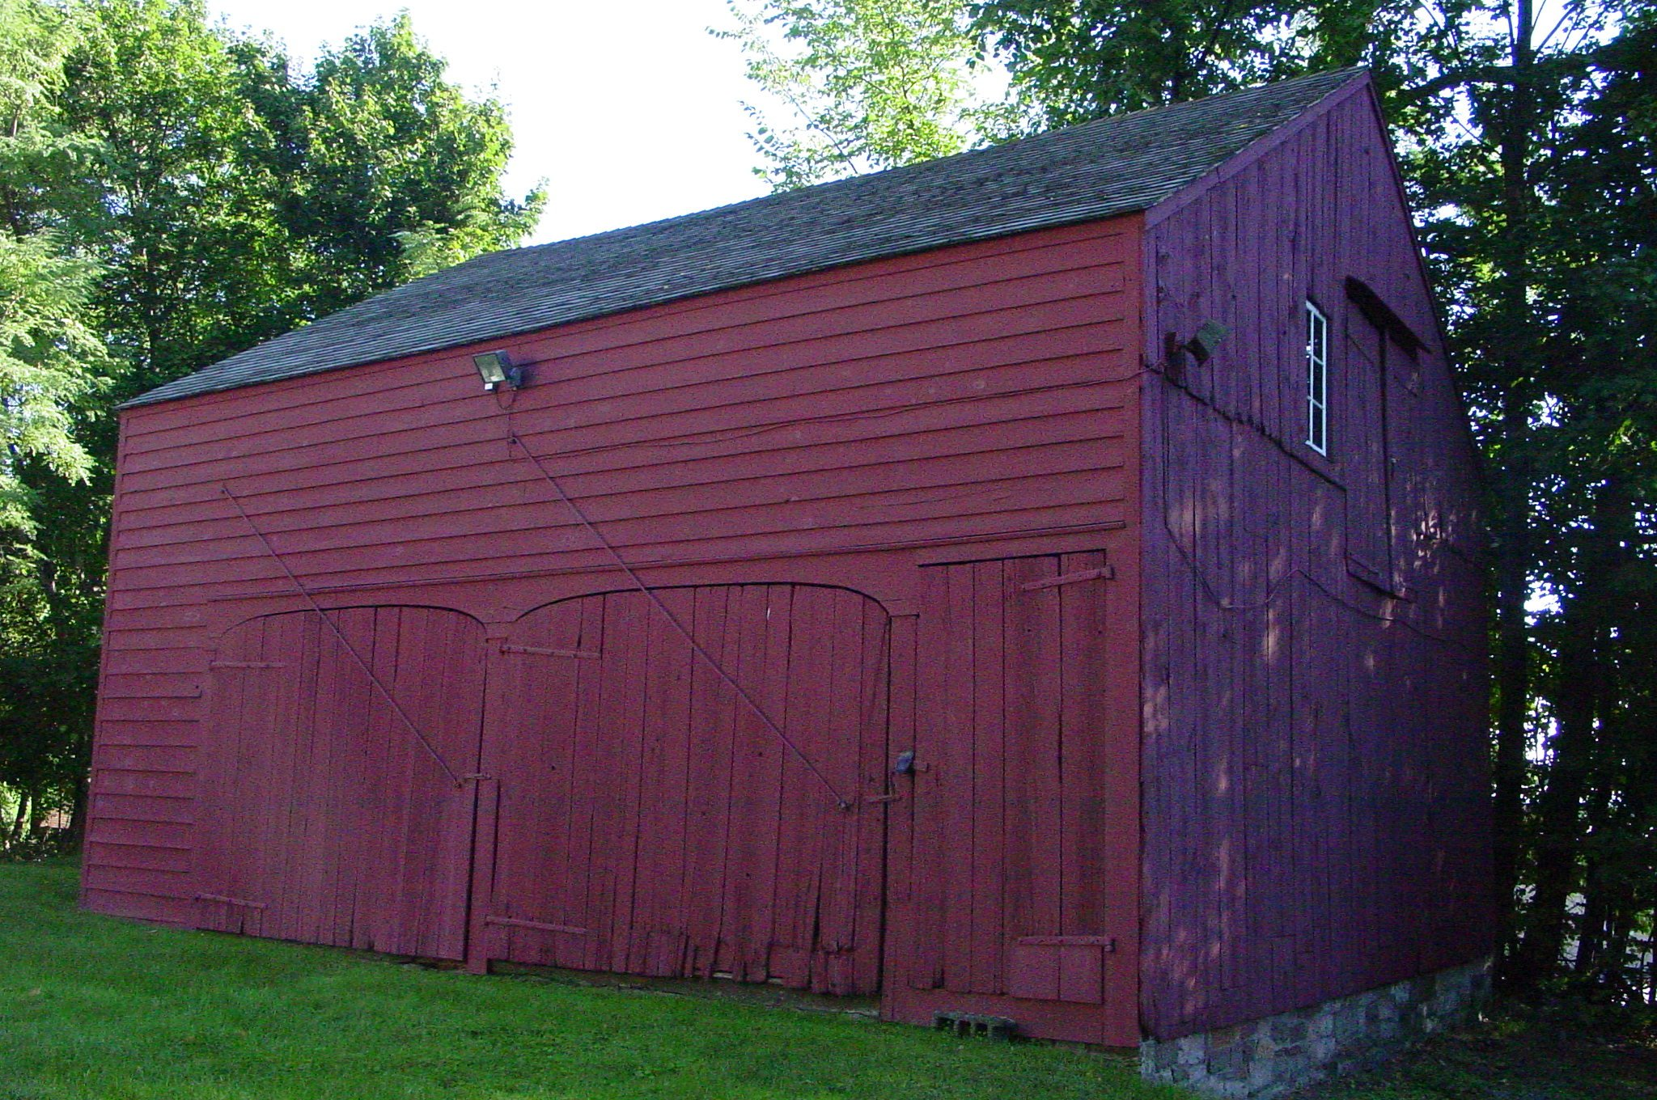
In 1965, the Society located a barn on the old Sly Farm (on Rt. 94, now the Landmark Inn) that seemed an ideal companion for the Shingle House. The barn was built around 1825. Through the generosity of Mr. and Mrs. Madison Lewis, the barn was disassembled piece by piece, including the hand-cut stones of its foundation, and was carefully reconstructed behind the house. It is a display and storage area for many early American tools and agricultural implements, many of which are from farms in the Warwick area.
In the early days the men of Warwick were definitely “of the land”. Most of them had dairy herds and also raised crops such as hay, rye, corn, oats and wheat, along with what we call “truck” vegetables now—peas, beans, onions, carrots, squash, potatoes, etc. They also frequently had an orchard crops such as apple, peach, and pear. A family’s survival could hinge on whether or not a tool was in good repair when needed, and many of the tools were personalized by making the handles a custom length and fit for an individual. With this in mind, it’s entirely true that to hold one of these tools is to shake hands with some of Warwick’s early residents.
In the barn we find tools of many descriptions and uses such as adzes, sickles, axes, flails, hay knives, corn knives, pitch forks, grain forks, scythes, and rakes. Larger implements include wheelbarrows, ploughs, seeders, a fanning mill, a grain cradle, a beet press for sugar beets, a corn-sheller, a feed carrier for taking feed to the cattle, and an old Amish hand-drawn cart for corn, hay or grain.
Other hand tools include buck-saws, hammers, mallets, chisels, pliers, cutters, planes, bits, tool sharpening grinder, milk cans, early lanterns, harnesses and bridles. Visitors will also find a candle-making rack, spinning wheels, yarn carders, butter churns, cider vats, a wine press, maple syrup kettles, old wood stoves, skates, sleds, school desks, small wagons, and a baby carriage.
Household use appliances are also in the collection, including what is reported to be Warwick’s first bath tub (zinc inside a wood frame). One special group of artifacts is the ice-cutting and storing tools: a sledge, huge saws, hooks, tongs, rollers, and picks. There are also two horse carriages – one a phaeton with handsome top and upholstery, the other a rubber-tired runabout with candle lamps—and six old sleighs.

The Old School Baptist Meeting House

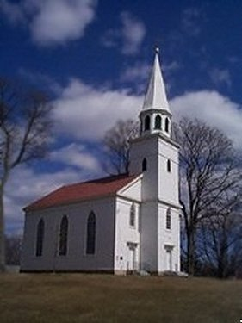
Built on what was then called a “sightly knoll in the village”, this beautiful house of worship was placed right in the middle of Warwick, and wherever you are in the community, you can see its lovely steeple pointing skyward. The handsome structure was the third home of the Baptists, the first being a log house erected by the eighteen members who came from Connecticut in 1765. It was the only Baptist Church in Orange County and, as such, by 1773 needed larger quarters—so a new one 36 by 40 feet was constructed, with galleries and movable wooden seats. Both were located on what is now the corner of Galloway Road and Forester Avenue. The first pastor was Elder James Benedict.
Between 1776 and 1778, attempts were made to move part or all of the congregation to the Westmoreland area of Pennsylvania. However, the continuance of the war and its accompanying raids--such as the disastrous Wyoming Massacre-- eventually resulted in a decision to remain in Warwick.
In 1819, finding that the log building was too small for a congregation of nearly 150 persons, the Baptists constructed their new Meeting House. It was 65 feet long by 45 feet wide, with a steeple 94 feet high, topped by a 9-ft. weather vane. It seated about 500 people on the ground floor and in the gallery that ran around three sides. The design was by Deacon John Morris Foght (also spelled Fought) who also carved the lovely golden dove with an olive branch in its beak—“Emblem of Peace”—which was poised away above the beautiful wine-glass pulpit, the building’s most elegant feature. In 1864 the original pulpit was replaced by a lower one; but in 1959, that was removed and a second wine-glass pulpit copied after the one in the Old School Baptist Church in Slate Hill NY was installed. Above it, a sounding-board almost identical to the one there originally was placed. At the top of the plaster arch which ornaments that end of the church there has always been a keystone-shaped panel bearing this inscription: “Hitherto hath the Lord helped us—Praise Ye the Lord.” Most unusual were the twelve many-paned windows, some two-sash style, each sash 12-over-12; and there are even some three sash types, 24-over-24-over-30.
By the mid 1800’s, the congregation of this church began to decrease. This was due to many things—the organization of other Baptist churches in Orange County and nearby counties, the movement of people to the West; and, most importantly, the nation-wide division of the Baptist Church, resulting in a split in Warwick and the creation of the “New School” or Calvary Baptist Church. Only those holding to the old beliefs, known as the “Old School” Baptists, remained to make up this church’s congregation. They became fewer and fewer in number, until in March 1951 the two surviving members came to the Historical society offering to transfer the property to the Society if it would keep it consecrated as a religious building. It seems that by state law, an abandoned church could be taken over by the state and be demolished and the land sold. Determined that his fate should never overtake this lovely landmark, the Society mounted a campaign to raise enough money to repair the roof, paint the outside, and gold-leaf the weather-vane. And on July 27, 1952, a celebration was held at The Shingle House, when the deed was given by Mrs. Isaac Dolson of the congregation to Lawrence Stage, then Treasurer of the Society and Custodian of its records.
In 1957 restoration was started in earnest, to bring the building back to its original appearance. Two years later, the new wine-glass pulpit (also known as a candlestick pulpit) was installed. Old stoves and chimneys which warmed the congregation were removed; much patching and painting were completed. The interior is now off-white, but one section still bears the original, soft lovely purplish color of the olden days.
Each year, on the last Saturday of July, known in Warwick as Washington Day because it commemorates the day in 1783 when George Washington stopped at Baird’s Tavern for a “drink of grog”, the Society holds its annual picnic on the lawn of the church then goes inside to hear a speaker on patriotic events or customs, a play, or a musical program. And each December 24th members and friends fill the church to hear the Christmas story read and sing Christmas carols. Many weddings are also held there every year, and it was used as a location for the movie “In and Out”.
The church is sited on what is now Lewis Park. It is also interesting to know that where many of lovely views of the church now exist, there were formerly old houses that were purchased and taken down by the Lewis family to create this green space in the village, and to give the church a more beautiful setting. Location: Lewis Park, adjacent to Main St., between Church and High Streets.

The 1810 House

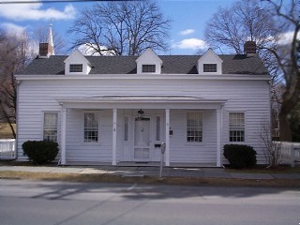
When you see this charming, early 1800’s cottage standing in all its beauty on Main Street opposite the Village Hall, you would never guess what a busy life it has led. Built and first occupied by the Olmstead family, it has had many owners including Bradners, Wellings and Hoyts. In the 1870’s it became the home of the Warwick YMCA, with a large gymnasium built behind it; and one of the front rooms housed the town’s second library. In 1931 it became the headquarters of the American Legion. And finally, in 1955, it was bought by Mr. and Mrs. Madison Lewis. Over they years, they had it completely restored. In October 1976, it was deeded to the Society.
Sturdily constructed, it is a Connecticut saltbox in its roof lines and Dutch in its dormers. As it was restored to its original appearance, down came the gymnasium and the inside was thoroughly transformed with woodwork, wallpapers, paint and hardware until it truly reflected the warm character that was its birthright. Under the sloping rear roof, a shaded brick terrace leads to a well-house and a boxwood-enclosed wheel garden of fragrant, old-fashioned herbs. One gate of its white picket fence leads to the Old School Baptist Meeting House, an old friend built at the same time; another gate opens into Lewis Park, whose paths, benches and plantings make a picture reminiscent of the house’s beginnings.
Inside, the first floor is devoted to exhibits. On the left is the “Forester Room” which contains mementos of Henry William Herbert, also known as “Frank Forester”, famous sportsman of the mid 1800’s. One of his best known books was Warwick Woodlands, first published in 1839. It is a paean of praise for the hunting and fishing in the forests and streams of the area. Writing also under his true name of Henry William Herbert he turned out many books, and most of them are found here in this room. He visited Warwick whenever he could, making as his headquarters the old Wawayanda Hotel. It was built in the late 1700’s just a short distance from both the Shingle House and Baird’s Tavern, on the corner of Colonial Avenue and Main Street where a gas station now is. An original mantel from that historic hostelry tops the fireplace of this room. Many of Forester’s hunting accessories, carefully assembled by Roy Vail and given to the Society by Lawrence Stage are displayed, including a game bag of badger skin, dram bottle, match safe, knife, bait box, wild pigeon decoy, powder-and-shot flask, and wolf, bear and beaver traps.
This room also features a Hepplewhite sideboard, a Revolutionary officer’s fan-back Windsor chair, a stable chair owned by William H. Seward, a Village of Florida native. He was Lincoln’s Secretary of State and the man who bought for the nation “Seward’s Folly” as it was called then—Alaska. The two side chairs were once owned by Sargeant Phillips, one of George Washington’s “life guards”. There are also an early Queen Anne table and an old gate-leg table, and many shelves of historical reference books and genealogies.
At the right of the front door is another living room. It contains a Sheraton desk, a huge Dutch kaas circa 1740, a child’s high chair used by New York’s first governor, George Clinton, an antique doll collection and doll accessories. The mantel over a brass-trimmed Franklin stove built right into the fireplace came from one of Warwick’s first stores, which stood where the Wisner Library is now. There are also several needlepoint pictures, a brass-studded trunk, and old lamps. Location: Main St. at Lewis Park, between Church St. and High St.

Herb Wheel at the 1810 House

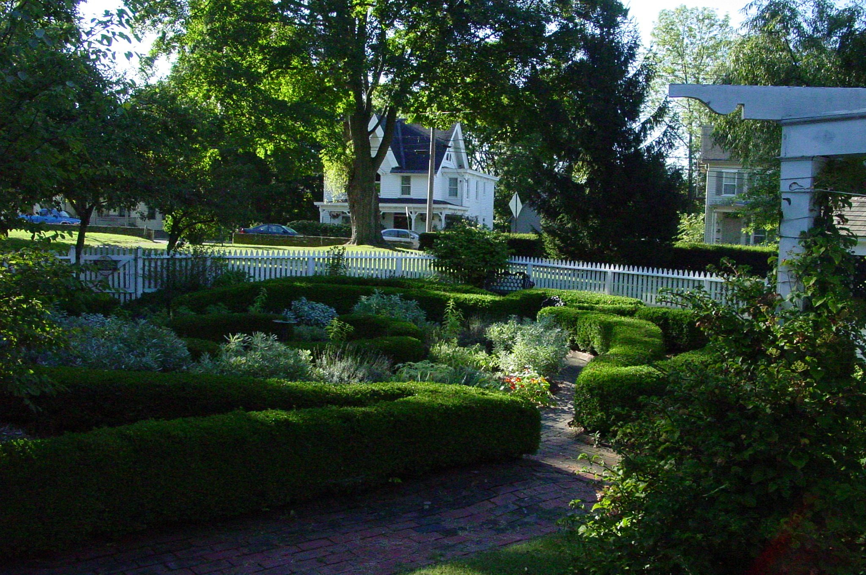
The herb wheel garden in the rear of the house was planed in 1957 by Mrs. Charles Reed and Mr. Ralph Shaeffer. It was a project of the Orange and Dutchess Garden Club. The site of the garden was at that time a barn-like building adjoining the house that had been home to the American Legion, YMCA gymnasium, and the American Legion. When it was removed, Mrs. and Mr. Lewis’ architects for the adjoining park added boxwood corners and the picket fence that enclosed the whole back yard.
The garden is an authentic copy of an herb garden in the period of the house. It was designed for fragrance and contrast of textures. Each quarter contains both perennials and annuals. The perennials include sages, hyssop, nepeta (catmint), orris root iris, lambs ears, and Lady’s Mantle. A thick matting of thyme in the center surrounds the strawberry jar. The garden is still maintained by the Garden Club of Orange and Dutchess.

Azariah Ketchum House

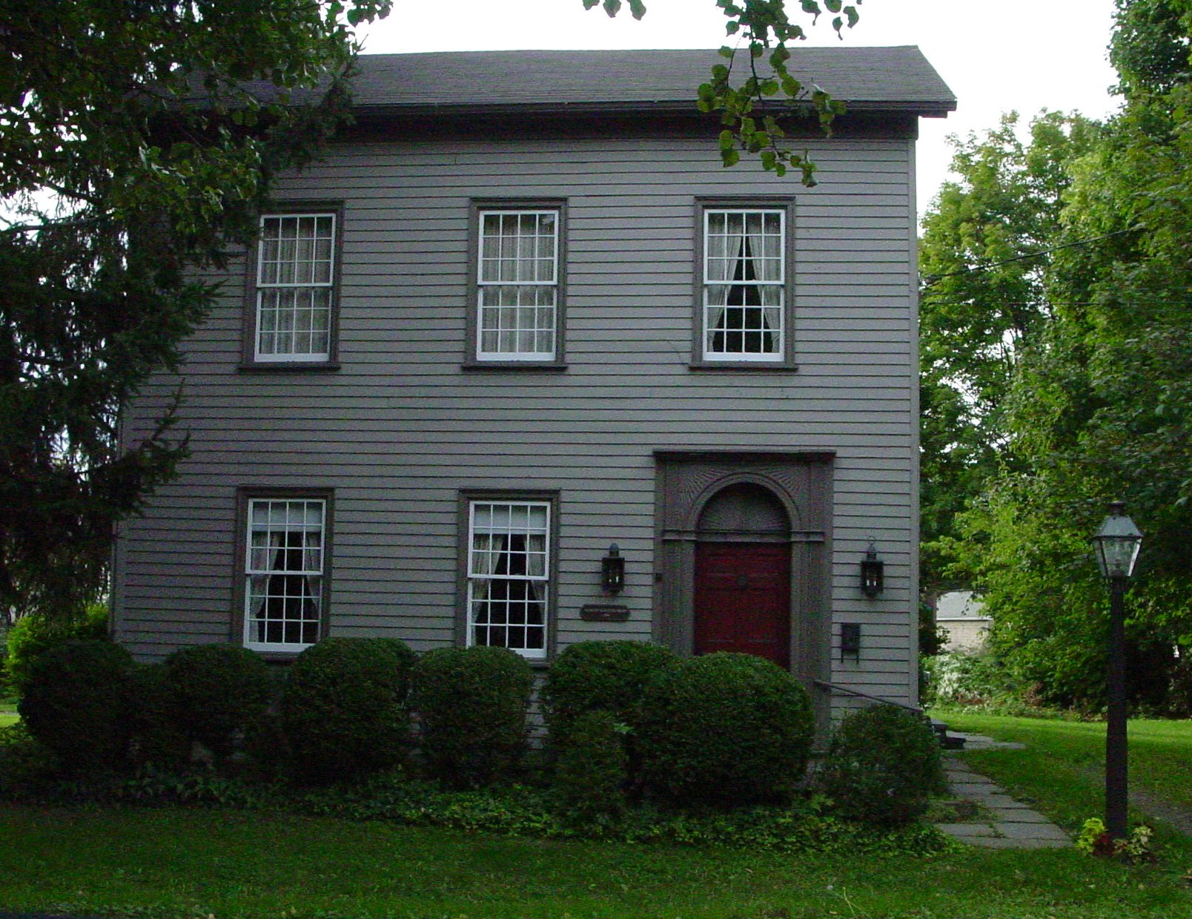
At twenty six Church Street is the home of master carpenter Azariah Ketchum, one of the builders of the Old School Baptist Meeting House. This small Federal house was most likely built around 1810, when he was working on the church.
Azariah was born in Bedford, in nearby Westchester County. Azariah’s family soon moved to a large farm on the old Warwick-Greenwood Lake Road. Ketchum served in the Revolution under Col. Hathorn. In 1781 he married Elizabeth Thorp, daughter of a neighboring farmer on Chuck’s Hill. About this time, the Ketchums spent some years in New York City, Azariah probably working at his trade as a carpenter and house wright. They returned to Warwick in 1809. Experience in Manhattan would account for the style of this house, for there is no other example of the Federal period in the village, and perhaps the entire township, of Warwick. Azariah proudly built his little house, which has a floor plan similar to the typical Manhattan brownstone. It has two rooms one over the other, a hall, attic and a cellar. It has high ceilings, elaborate mantles and main doorway, and a graceful stair that is continuous to the attic. It was really very citified and ‘new fangled’ for Warwick in 1810!
The structure was rescued from disrepair and gradually returned to much of its original appearance by Mrs. Ray E. Bennett in the 1970’s, with the help of the Society’s revolving restoration fund. She added a compact wing to the rear, and which the last work of Henry Ten Kate, who had meticulously reconstructed the Sly Barn at the Shingle House.
After restoration work by John Burgess of Montgomery, Mrs. Bennett deeded the house to the Society with the provision for her use during her lifetime. The front step of the home is an old flat stone slab that was once a well cover, with the large circular hole for the bucket filled in to prevent accidents. It is now a private residence for the Society’s curator.

Baird’s Tavern

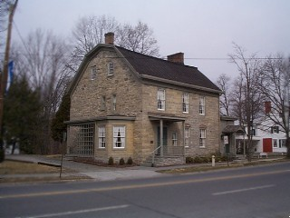
One of the most notable buildings on Main Street is the limestone structure standing opposite the corner of Colonial Avenue. It was here on “The King’s Highway”, that ran between Pennsylvania and New England, that Francis Baird built his tavern in 1766. He brought masons and carpenters from New York City to what was then for the most part an unsettled valley. He constructed it as an inn to serve Colonial travelers, and the inn and store served a vital role in community life. Many notables of the time stopped here, including George Washington, who recorded in his diary the purchase of some grog here in 1783. On December 6, 1782, the Major General of the French Army, serving under Count Rochambeau, stayed all night here with his aides. He records this in his published “Travels in North America in the years 1780, ‘81, ‘82”:

“Warwick, where I slept, a pretty large place for so wild a county.. I lodged here in a very good inn kept by Mr. Smith [ed. note: Mr. Smith bought the tavern from Francis Baird] …The American army having for two years past had their winter quarters near West Point, Mr. Smith imagined with reason that this road would be more frequented than that of Paramus…” – “The Baird Family” by Ferdinand Van DerVeer Sanford in Warwick Historical Papers, vol. 1.

The tavern went through a succession of owners, including for many years W. B. Sayer who furnished the “Washington Room” as it was known then with many relics of the past era. Mrs. Elizabeth Sanford Van Leer donated funds for its purchase by the Society in 1991. It was gradually restored by the Society to its original appearance as a colonial tavern and inn, as nearly as possible, and furnished appropriately.

The archive of the Society contains one of the original financial ledgers of the inn in 1785 and 86, when it was run by a Mr. Smith. It was presented as a gift by Eugene Wright in memory of his father and mother Betty and Eugene Wright. Photocopies of an earlier ledger now in private hands also are owned by the Society. Location: Main St. opposite the intersection of Colonial Ave.

The Carriage House at Baird’s Tavern

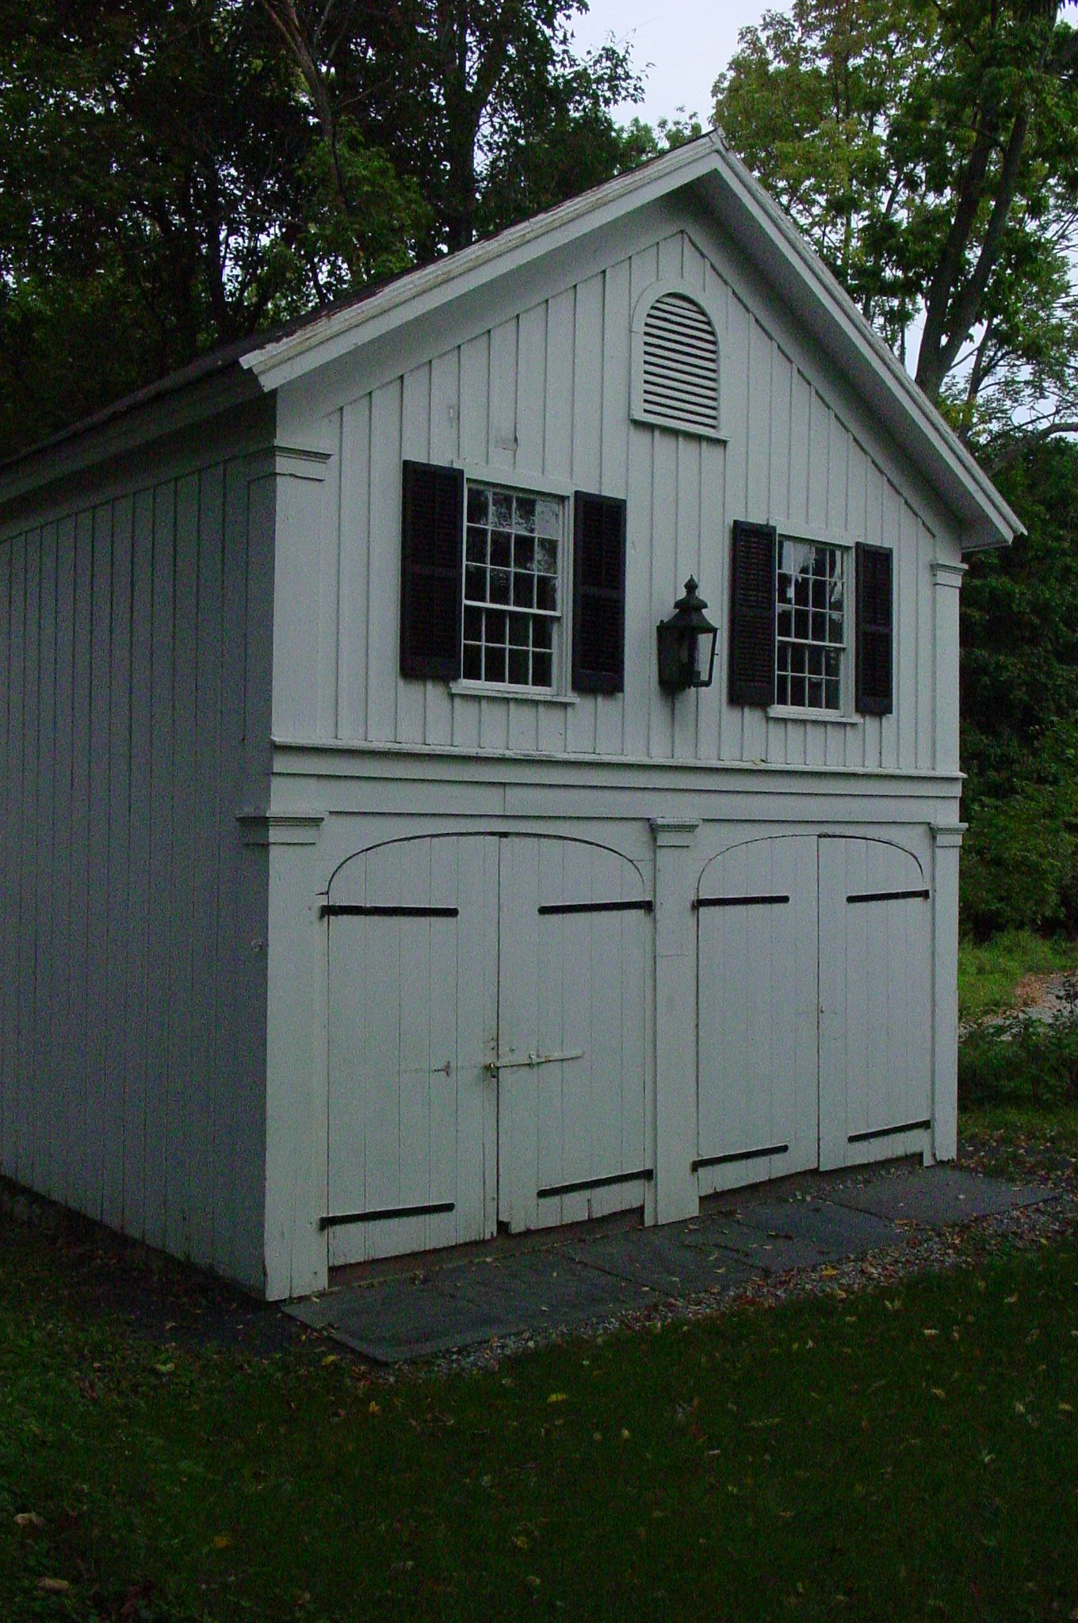
The newest of the Society’s buildings is the carriage house behind Baird’s Tavern, which was donated by Key Bank in 2001 and moved still erected from the bank’s property next door. The lower floor remains much as it was when carriages were stored here in the last century, and the upstairs has been re-created as a country doctor’s office of the early 1900’s. Many of the items came from the estate of Dr. Morris R. Bradner, Sr., who headed the establishment of Warwick’s first hospital. They were presented by Mary Bradner, and additional donations were given by David and Patricia McConnell and other members of the community. The office includes many antique medical instruments, tools, and memorabilia. It was opened to the public for the first time in September of 2002.

Don't forget to visit Warwick history on the Web!
www.warwickhistoricalsociety.org
AND
www. albertwisnerlibrary.org
click on "Local History"

